

BOMMIREDDY SRIVANI

# CAREER OBJECTIVES

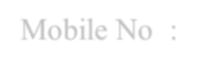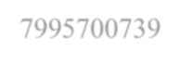

Address : Hno:1-175 , Kotapadu(V), Kolimigundla(M), Kurnool(D), Andhra Pradesh

Email : [bommireddysrivani@gmail.com](mailto:bommireddysrivani@gmail.com)

Mobile No : 7995700739

Seeking a responsible position in an organization that offers me a consistently positive

atmosphere to excel in my career and to use my skills in the best possible way for achieving the organization goals.

# EDUCATION QULIFICATION



|  |  |  |  |  |
| --- | --- | --- | --- | --- |
| **Academics** | **Institution** | **Board/**  **University** | **Year of passed** | **percentage** |
| B. Tech (CDS) | Ravindra college of Engineering for women Kurnool | JNTU-  Anantapur | 2021-25 | 82.72% |
| Intermediate (MPC) | Chaitanya Junior College  Hyderabad | Board of Intermediate TS | 2019-21 | 96.4% |
| SSC | Montessori  English Medium School , Kurnool | Board of Secondary School  Education AP | 2018-19 | 95% |

 **TECHNICAL SKILLS**



* C Language
* Python
* Java
* Basics of HTML
* Basics of CSS
* Basics of MYSQL

# SKILLS

* Project Management
* Leadership, interpersonal and communication skills
* Adaptibility to change
* Creativity team work

# INTERESTS & HOBBIES

* Cooking
* gardening
* Volunteering
* Yoga
* Sports (Kho – Kho , throw ball, tennikoit)
* Other interests such as listening Music

# CERTIFICATION



* NPTEL Certification for Successfully completing the Object oriented through Java
* Sololearn Cerificates on Introduction to HTML, Introduction to Java, Python for Data Science.
* I have attended a Workshop on Data Science.
* I have participated in training of Linux Essentials which was conducted by C-DAC.

# INTERNSHIP CERTIFICATE

* AICTE- Eduskills Process Virtual Internship
* AICTE- Eduskills Cyber security Virtual Internship
* AICTE- Eduskills Alteryx Data Analytics Process Automation Virtual Internship.
* I have done an internship on Web Development provided by the coincent company.

# PROJECT

* I had worked on the project named smart parking System. Where I had collaborated with a team to design and develop a Smart Parking System aimed at optimizing parking space utilization.
* I had done a mini project of Password Generator using python.
* Qualified in first round of ISRO Robotics challenge URSC – 2024 in rover making and working on second stage of project.





**PERSONAL DETAILS**

Name

: B. Srivani

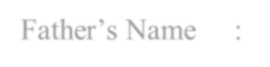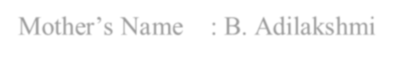

|  |
| --- |
| Date of Birth : 17-09-2003 |
| Father’s Name : B. Venkateshwara Reddy |
| Mother’s Name : B. Adilakshmi  Languages known: English and Telugu |
| **DECLERATION**  I here by declare that all the above-mentioned information is true and correct to the best of my |
| knowledge.  SIGNATURE |



B. Srivani